(Approx. 1169 words)

Cast your Smartphone – What your Smartphone?
By Phil Sorrentino, Newsletter Contributor, Sarasota Technology Users Group, FL
June 2016 issue, STUGMonitor
www.thestug.org
Philsorr.wordpress.com
philsorr (at) yahoo.com

How would you like to show all the pictures that are on your phone, on your big screen TV? HDMI comes to mind as an obvious solution; just get an HDMI cable, connect it up, and sit back and watch. But unfortunately, most phones don’t have an HDMI output port. (Most laptops have an HDMI output, so you may already be doing this with your laptop, an HDMI cable, and a big screen TV.) So, without HDMI on your phone, it will have to be accomplished by some other mechanism. Another, maybe obvious, way is just to move the pictures to a device that has HDMI and use your trusty HDMI cable. You can move your pictures to a laptop using USB, or a Micro SD card (if you have a port on your phone), or the Wi-Fi App (see the January 2017 article). Once your pictures are on the laptop, you can use the HDMI output and enjoy the presentation on the big screen.

If you still want to have the convenience of going right from your phone to your big screen TV, you are in luck, there is another mechanism. While you and I were just thinking of the problem, the Wi-Fi Alliance has been busily creating a solution. The solution is Miracast. Miracast is a standard that attempts to eliminate the need for HDMI cables. It provides a wireless standard that allows devices to discover each other, connect to each other, and mirror the contents of their screens wirelessly. Miracast is a standard for a secure wireless connection from devices (such as Smartphones, Tablets, and Laptops) to displays (such as TVs, Projectors and Monitors). Miracast essentially replaces the cable used from the device to the display and can casually be describes as HDMI over Wi-Fi. Miracast securely transfers both high quality video (1080p HD) and high-quality audio (5.1 surround sound).

Miracast is intended to be interoperable, that is, it should work between devices that are Miracast certified, independent of the manufacturer. The Wi-Fi Alliance began certifying devices towards the end of 2012, so there should be plenty of devices available; in fact, to date there have been over 6,600 devices certified. Microsoft has added support for Miracast to Windows 8.1 and Windows10. Google has added support to all Android versions beyond 4.2. (Apple provides AirPlay which has similar features but will only work with other Apple devices.) There are even adapters that plug into HDMI or USB ports, allowing devices without built-in Miracast to connect via Miracast.

So, Miracast appears to be the solution. But, this is where reality goes in a little different direction and diverges from design. Although Google was an early supporter of Miracast (by including support in early Android versions), when Google built a device that could be used to display a phone’s screen on a big screen TV without wires, they did not include Miracast in the device, (though Miracast may still be the solution in the future). Google’s device is called “Chromecast”. It is about the size of a silver dollar with HDMI and USB connectors, and can be purchased for about $35. The HDMI connector is plugged into a free HDMI connector on the TV, and the USB connector provides power by plugging into the TV USB, or any other available USB connector. The Google Chromecast device does not support Miracast, though it does a very similar function. It allows a remote device (your phone) to display (or mirror) its screen on the TV (display) that the Chromecast is connected to, without using an HDMI cable between the phone and the TV. The Chromecast device (as well as other Google Home devices) is controlled and setup using a free App on the phone. The App is called “Google Home” and is available at the Google Play Store.
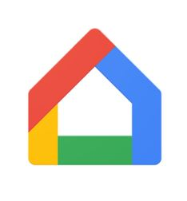Google Home Icon

As it turns out now, Google’s solution seems to be like Apple’s solution, in that it may only work with Google devices, although the Home App is available for both Android and Apple’s iOS, so it may work with an iPhone.

Now, let us get back to solving the problem of showing your pictures on the big screen. With an Android phone, the easiest (and maybe cheapest) way to get those pictures on to the big screen is probably to use a Chromecast device and the related “Home” App. So, here is what we must do. Download the Home App to your phone and put it on one of your convenient home screens. Connect your Chromecast to an unused HDMI input on your TV. Turn on the TV and change the TV input to that specific HDMI input. Plug the USB connector on the Chromecast into a USB plug (on the TV or from a wall adapter). There is only one light on the Chromecast and it should eventually turn white. Start the Home App on your phone by touching the App. (Note: your phone and the Chromecast must be on the same Wi-Fi network.) Once the App starts, touch the menu icon in the top left of the screen.
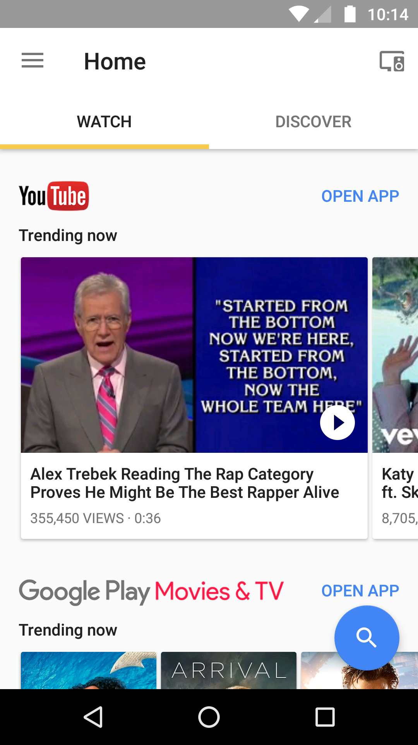 Opening Screen
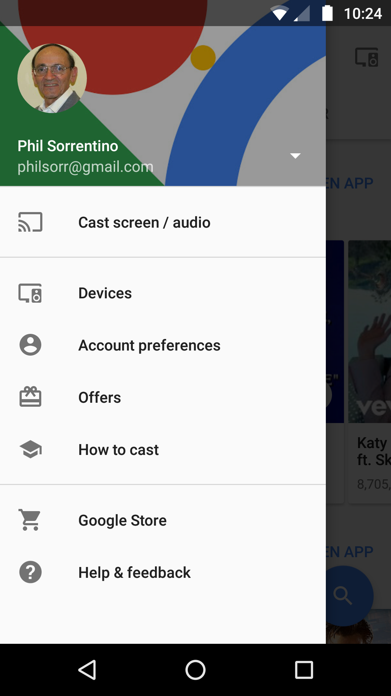 Touch Menu screen
This will present a screen with “Devices” in the list. Tap “Devices”. Follow the set-up instructions to set up the Chromecast. Finally, a Chromecast screen will be shown on your phone and a background picture should be shown on your TV. (Both displays will show the Chromecast Identification, of your Chromecast device, towards the top on your phone, and on the bottom on the TV.) Once you see this display, go back to the screen where you found “Devices”, and touch “Cast screen/audio”, which will show a “Cast to” selection. Touch the Chromecast Identification, and a connecting notification should show up. When the connecting notification goes away, you are connected, and your phone screen should be displayed on the TV. Voila, now your phone screen is being shown on the TV, so go to your favorite Picture Viewer and show your pictures. (In fact, at this point anything you do with your phone will be shown on the TV, so be careful.) When you are finished showing the pictures, go back to the Home App on your phone and touch “Cast screen/audio” again, and on the next screen, touch “Disconnect”, and the TV will no longer show the phone screen.

Just as an alternative, if you have your pictures on a laptop and you have Windows 10, you can display your pictures on your big screen TV by using a Microsoft Wireless Display Adapter (approx. $60) connected to the TV. The Display Adapter is connected to the TV just as described for the Chromecast. On the laptop taskbar, click the Action Center, and then select the “Connect” button, which will connect your laptop with the Display Adapter via Wi-Fi and your laptop display will be reproduced on the TV.

